`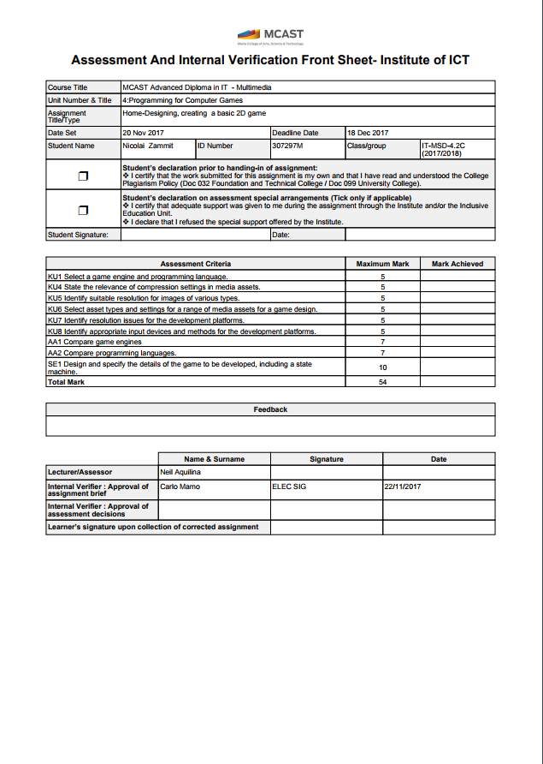

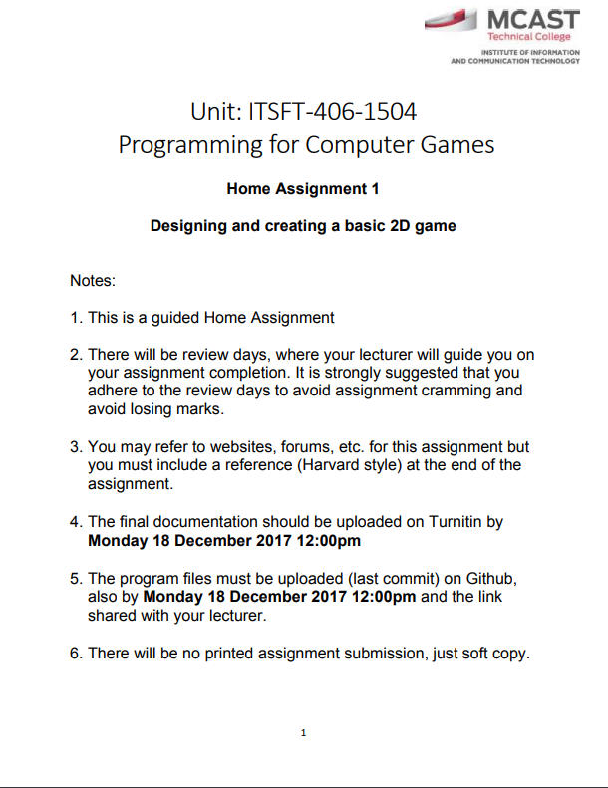

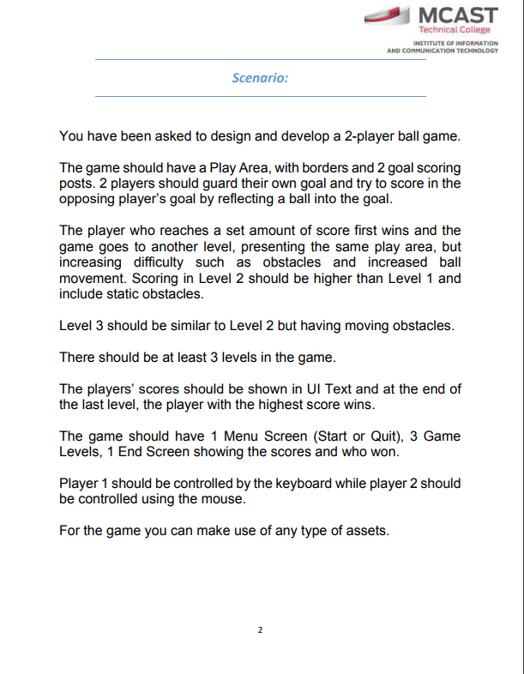

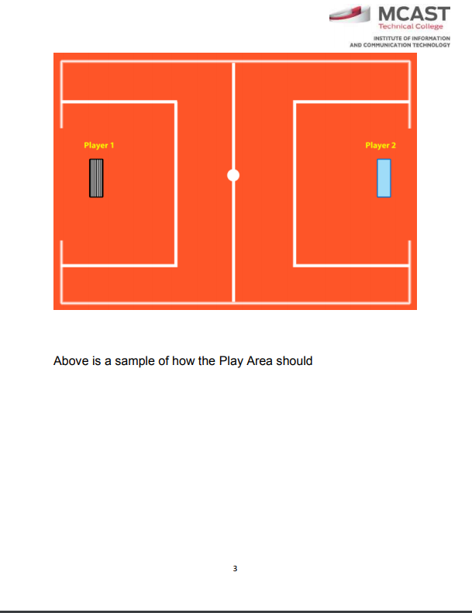

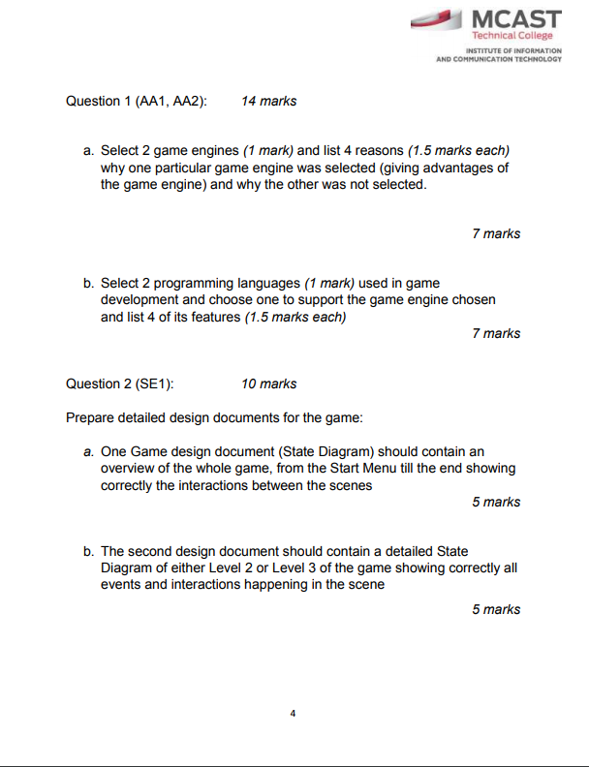

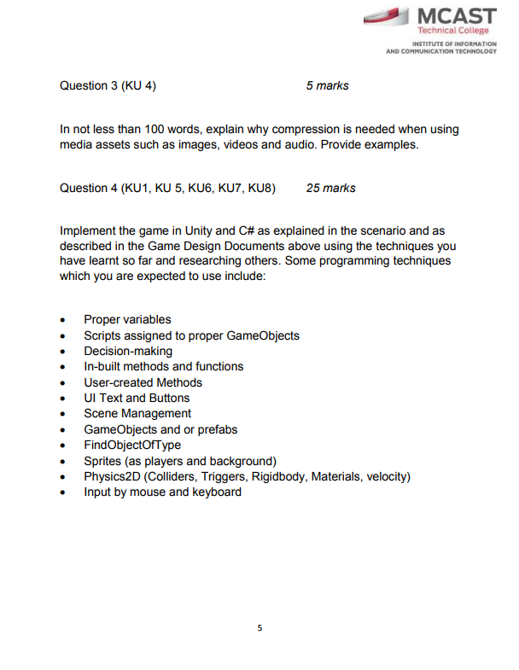

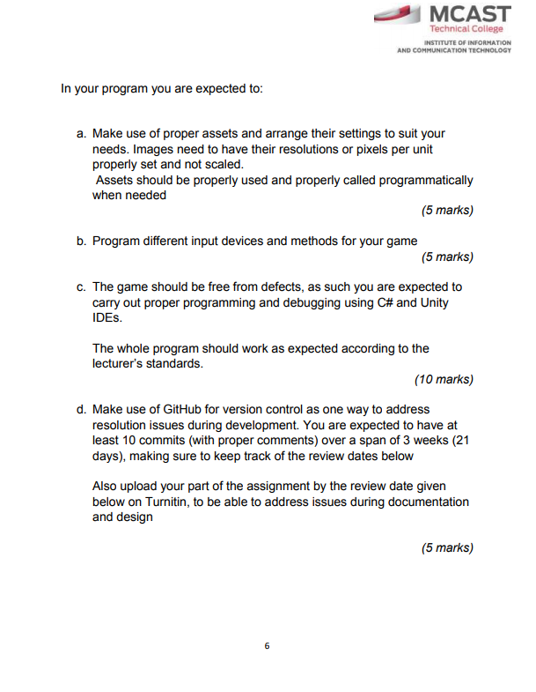

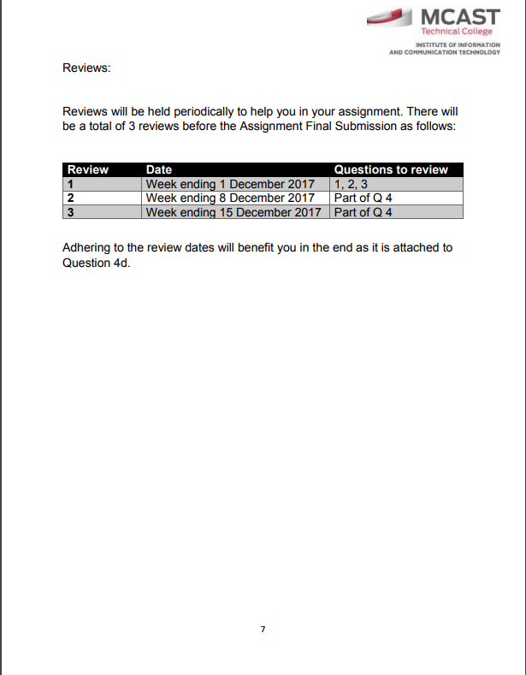

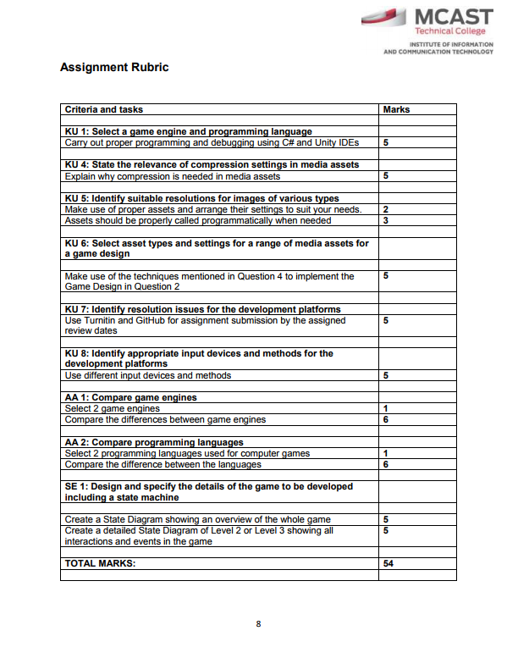

Question 1 (AA1, AA2):

Select 2 game engines (1 mark) and list 4 reasons (1.5 marks each) why one particular game engine was selected (giving advantages of the game engine) and why the other was not selected.

**Unreal Engine and Unity Engine.**

**Unity is chosen over Unreal.**

* **Unity can be used for free for those programmers/people that want to try out the engine and create simple games as practice and Unreal engine does not allow people to use their program unless they paid for the license.**
* **Unity has a larger community than Unreal engine, this way you can easily go to forums or any way to contact people from the community for help, advice and anything needed in your project.**
* **Unity is more productive in their programming language which is C# and Unreal uses C++ which is less productive when processing.**
* **Unity has a simple and fast structure that allows people to easily navigate through the engine while the Unreal engine has a more difficult structure to get hold off and it’s more for experienced people.**

Select 2 programming languages (1 mark) used in game development and choose one to support the game engine chosen and list 4 of its features. (1.5 marks each)

**C# and C++**

**C# chosen for Unity over C++ for Unreal Engine**

* **C# is an easy language to learn for beginner programmers, this way they will not have much difficulty writing and understanding their code.**
* **C# is more rapid and potentially less error-prone than C++ which means that there will be less unnecessary code complexity while programming.**
* **C# is well-structured; this way beginner programmers can easily understand and modify any needed code.**
* **C# is an object-oriented language which will make development of code easier rather than having other types of languages such as the procedural-oriented programming.**

Question 2 (SE1): 10 marks

Prepare detailed design documents for the game:

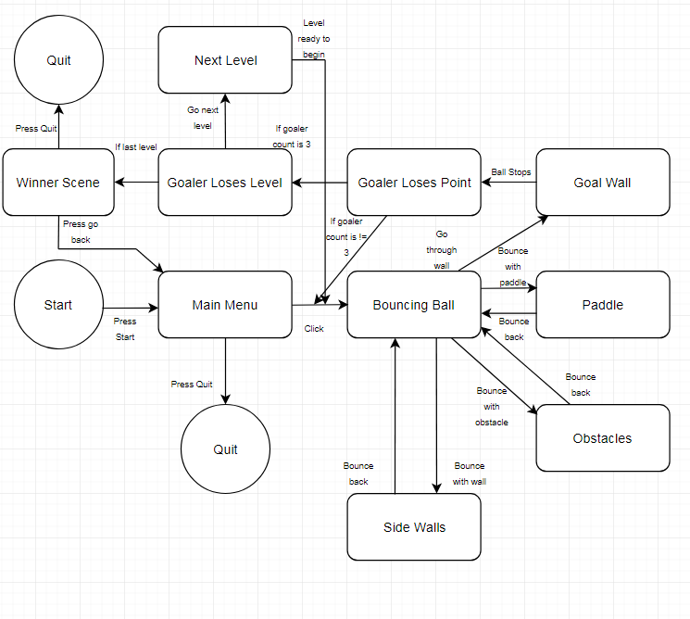One Game design document (State Diagram) should contain an overview of the whole game, from the Start Menu till the end showing correctly the interactions between the scenes.

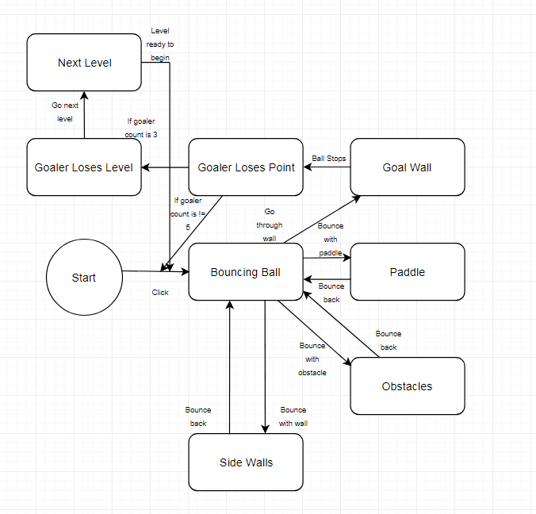The second design document should contain a detailed State Diagram of either Level 2 or Level 3 of the game showing correctly all events and interactions happening in the scene.

Question 3 (KU 4) 5 marks

In not less than 100 words, explain why compression is needed when using media assets such as images, videos and audio. Provide examples.

**Compression is a simple term of combining your files/assets such as images, videos, audio or even codes into a compressed zip file for example, this way it will save bandwidth and speed up the transfer of files/assets. When uploading files it can take a while for the computer to load your files, but it takes less time to upload compressed zip files to it is recommended to compress our assets first and then we upload to our game.**

**Efficiency will be better in our development of our game and will help us implement our game easier. There are two tables below that show the difference between not compressing your files and compressing your files in a website related example.**

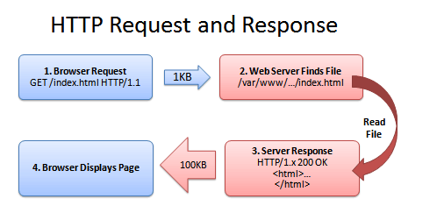

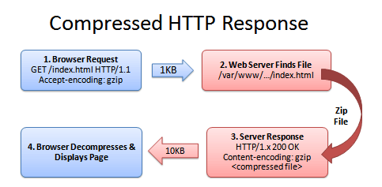

**References:**

**C# FEATURES - JAVATPOINT**

**In-text:**(www.javatpoint.com, 2017)

**Your Bibliography:**www.javatpoint.com. (2017). *C# Features - javatpoint*. [online] **Available at:** https://www.javatpoint.com/csharp-features [Accessed 28 Nov. 2017].

### ANON

**In-text:**(Anon, 2017)

**Your Bibliography:**Anon, (2017). [online]

**Available at:** https://www.quora.com/What-are-the-pros-and-cons-of-C-vs-Java [Accessed 28 Nov. 2017].

### C# AND ITS FEATURES

**In-text:**(C-sharpcorner.com, 2017)

**Your Bibliography:**C-sharpcorner.com. (2017). *C# and its Features*. [online]

**Available at:** http://www.c-sharpcorner.com/article/C-Sharp-and-its-features [Accessed 28 Nov. 2017].

### HOW TO OPTIMIZE YOUR SITE WITH GZIP COMPRESSION – BETTEREXPLAINED

**In-text:**(Betterexplained.com, 2017)

**Your Bibliography:**Betterexplained.com. (2017). *How To Optimize Your Site With GZIP Compression – BetterExplained*. [online]

**Available at:** https://betterexplained.com/articles/how-to-optimize-your-site-with-gzip-compression/ [Accessed 28 Nov. 2017].